
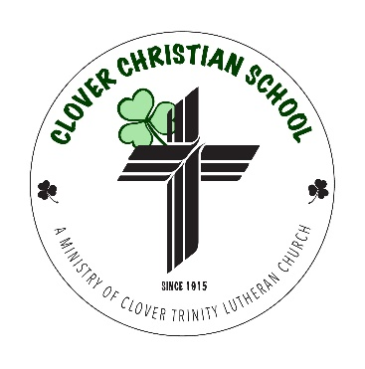
CLOVER CHRISTIAN SCHOOL
Tuition & Fees

2026-2027 School Year

GRADE  LEVEL | REGISTRATION FEE  (non-refundable) | TUITION | 1st CHILD  Monthly Payment  (10 Months) | TUITION | 2nd CHILD  Monthly Payment  (10 Months) | TUITION | 3rd CHILD  Monthly Payment  (10 Months)
Age 4-5  Kdg Readiness  4 Half Days | $150 | $3420 | $342 | SAME |  | SAME
Kindergarten  4 Full Days | $150 | $3950 | $395 | $3555 | $355 | $3200 | $320
First-Fifth  Grades | $225 | $5200 | $520 | $4680 | $468 | $4212 | $421
Busing is available for all grades.
Pre-Kindergarten students may ride the bus to school in the morning. We regret that return home transportation for Pre-K is NOT available. Appropriate social behavior for bus transportation is always required to maintain safety of students and staff. Services may be denied in non-compliance situations.

Non-refundable Registration Fee is due upon enrollment.
First tuition payment is due at Registration in August.
Busing is included in tuition.
Tuition assistance is available for grades K-5.
Receive a 5% discount on tuition if paid in full at Registration.
Card fees now apply to all payments.

Clover Christian School admits students of any race, sex, color, and national origin to all the rights, privileges, programs, and activities generally accorded or made available to students at the school. It does not discriminate based on sex, color, race, or national origin in the administration of its educational policies, admission policies, tuition assistance policies, athletics, or any other school-administered programs.

