Application for Tuition Assistance
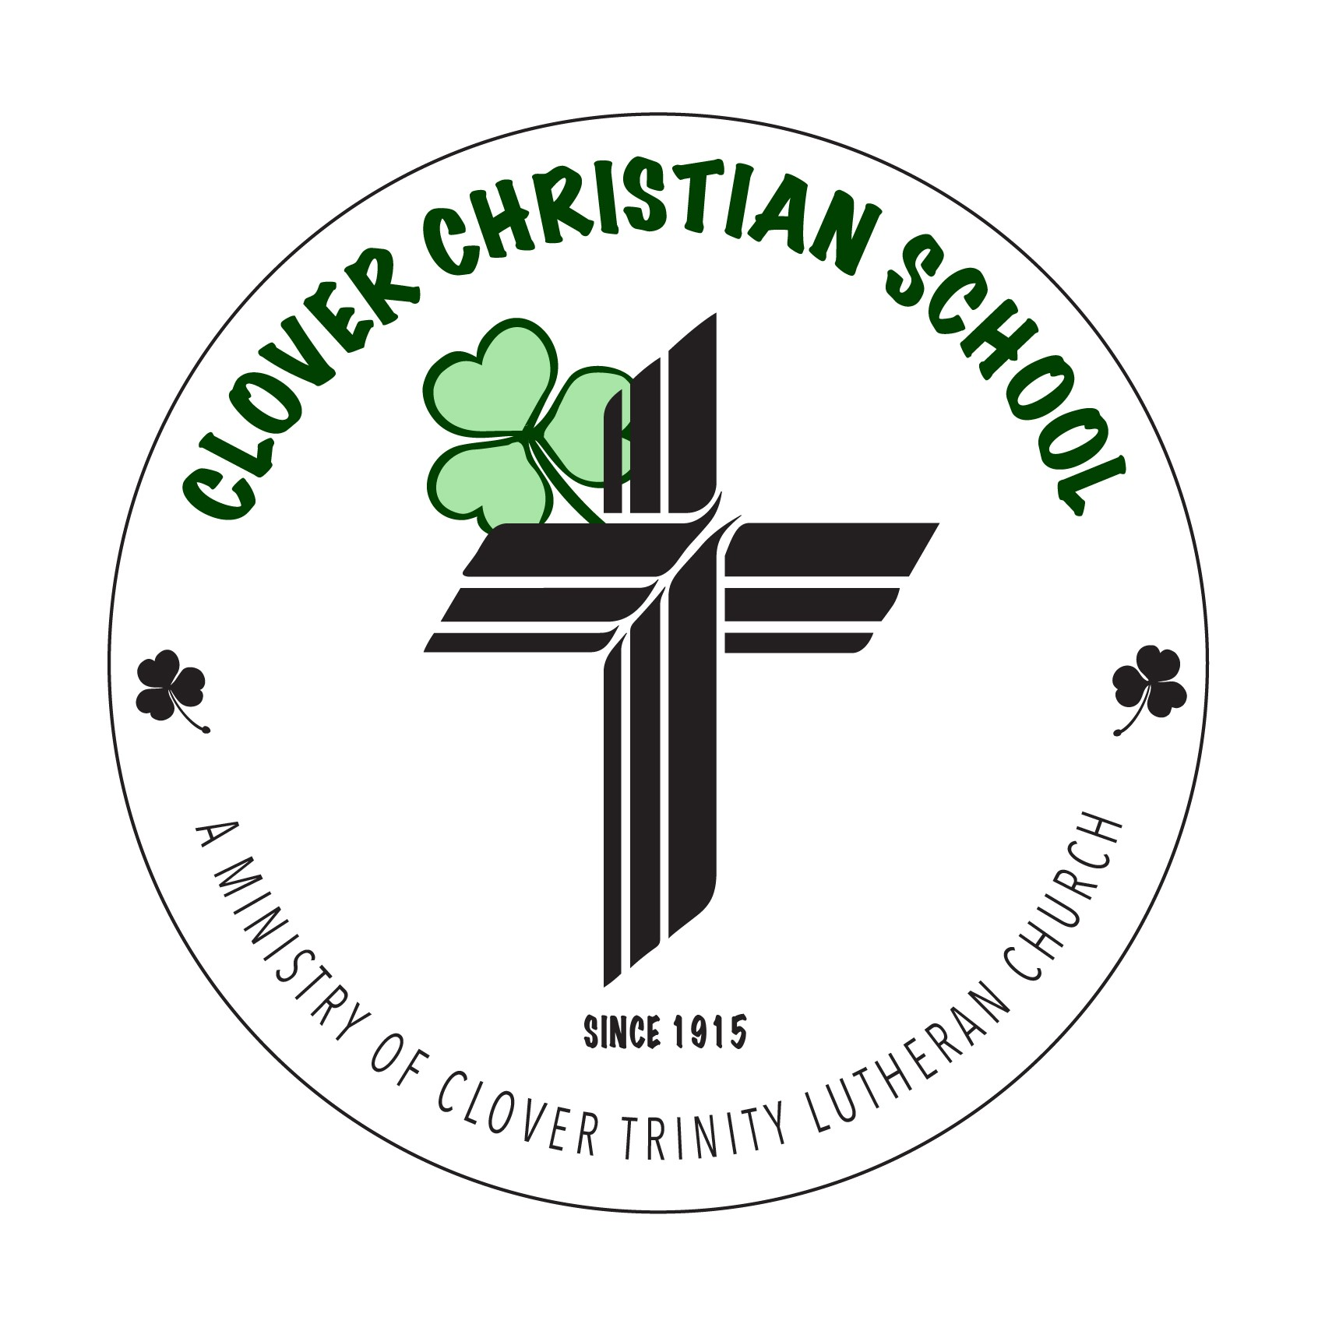
2026-27

Please fill out this form COMPLETELY and return it to the school office. Based on the analysis of this application and in light of any special needs indicated below, the Financial Aid Committee will determine the amount of tuition assistance your family may receive. Priority consideration will be given to applications that are received by the start of the school year.
PARENTS/GUARDIANS:  Name____________________________________________  Name____________________________________________ | DATE: ________________________  Occupation: ___________________________  Occupation: ___________________________
As of today, are you married? [ ] Yes  [ ] Yes, but separated from spouse  [ ] No (single, widowed, divorced) | Number of children enrolled at CCS last year:  ___________
Church Affiliation: ____________________________________________ | 2024-2025 Tuition paid in full? ___Yes ___No
List below children attending Clover Christian School | List Grade in 2025-2026
1.
2.
3.
List below children NOT attending Clover Christian School | List Grade in 2025-2026
1.
2.
3.

SINCERE STATEMENT OF INCOME **Please include income from ALL sources **
Adjusted Gross Household Income (Federal Tax Form 1040 or 1040A) for the year 2025: ________________
Current monthly income (Net take home from work):

Father: __________________/mo. AFDC or ADC______________/mo.
Social Security: ____________/mo.
Mother: ________________/mo. All child support: ___________/mo.
Other taxable income/benefits: ______________/mo.
Other Adult: _____________/mo. Other non-taxable income/benefits: ___________/mo.
**Do all of these adults contribute to the family’s monthly expenses, including the cost of school? __________
Please explain if necessary __________________________________________________________________

MONTHLY EXPENSES FOR WHICH YOU ARE RESPONSIBLE
Mortgage or Rent: _________/mo. Utilities & Insurance: _________/mo. College Tuition: _________/mo.
Auto Payments: ___________/mo. Childcare: ____________/mo. Medical: ______________/mo.
Child Support: ____________/mo. Debt payment: __________/mo. Misc. Debts: ___________/mo.
(Credit cards, etc.)

What special circumstances are affecting your ability to pay full tuition? Please explain in some detail so we can fully understand your challenges. Thank you!
__________________________________________________________________________________________________________________________________________________________________________________________________________________________________________________________________________________________________________________________________________________________________________________________________________________________________________________________________
__________________________________________________________________________________________

In what ways were you involved with Clover Christian School activities last year? (Returning families only)
______________________________________________________________________________________________________________________________________________________________________________________________________________________________________________________________________________
__________________________________________________________________________________________
Note: Financial Assistance applies to TUITION ONLY for Kindergarten – 5th grade and does not include registration fees. Clover Christian School reserves the right to review and cancel tuition grants at any time because of changes in a family’s resources, the failure to pay any outstanding tuition amounts, lack of cooperation with the child(ren)’s teacher, or a student’s failure to remain in good standing at the school - due to issues such as poor attendance or behavioral problems. We will notify you of your tuition grant awarded via letter as soon as your application has been reviewed.
Statement of Willingness to Partner with Clover Christian School in the Entire Education Process
I/We pledge that, as a condition of receiving tuition assistance, I/We will partner with the school in the education of my/our child(ren). This partnership will be demonstrated by, but not limited to:
- Arranging for my/our child(ren) to attend school regularly,
- Working with my/our child(ren) at home to support the learning they are doing in school,
- Being actively involved in the life of the school, attending school functions, and volunteering at school events or filling needs whenever possible,
- Understanding and supporting the religious nature of the school, and
- Supporting the school in word and deed with positive communication and marketing of the school.
All information on this form is true, accurate, and complete to the best of my/our knowledge. I/We intend to make regular and timely payments on the unsubsidized portion of our tuition and fee commitment.

Signature of Applicant: _______________________________________ Date________________________
Clover Christian School admits students of any race, color, national and ethnic origin to all the rights, privileges, programs, and activities generally accorded or make available to students at the school. It does not discriminate on the basis of race, color, national and ethnic origin in administration of its educational policies, admissions policies, scholarship and loan programs, and athletic and other school-administered programs.

